EXPT NO:2 | LOAD AND VISUALIZE A DATASET USING TABLEAU and PowerBI
DATE: 10.07.2026

PRE-LAB QUESTIONS (PROVIDE BRIEF ANSWERS TO THE FOLLOWING QUESTIONS)

1. Why is Tableau a preferred tool for data visualization?
Tableau is preferred because it provides an intuitive drag-and-drop interface, supports interactive dashboards, and can connect to multiple data sources. It enables users to create visually appealing and insightful reports without extensive programming knowledge.

2. What is the primary use of a line chart in data analysis?
A line chart is used to display trends and changes in data over time. It is especially useful for analyzing stock prices, sales, and other time-series data.

3. When would you use a tree map instead of a bar chart?
A tree map is used when you want to visualize hierarchical data or compare the proportion of different categories within a limited space. It is more suitable than a bar chart when there are many categories to compare.

4. What is the significance of filters in Tableau visualizations?
Filters allow users to display only the relevant data based on selected conditions. They make dashboards interactive, help focus on specific information, and improve data analysis by reducing unnecessary details.

5. How does Tableau handle geographic data for visualizations?
Tableau automatically recognizes geographic fields such as country, state, city, or latitude and longitude. It can generate interactive maps that allow users to visualize and analyze location-based data effectively.

IN-LAB EXERCISE:
OBJECTIVE:
To load a dataset into Tableau, create a variety of visualizations, and derive insights from the data using different chart types available in Tableau.

PROCEDURE:

Dataset Selection:
Use the Global Superstore Sales Dataset (available on Kaggle or Tableau's sample datasets).
Ensure the dataset includes fields like Order Date, Category, Region, Sales, Profit, and Customer Segment.

Data Loading:
Open Tableau and connect to the dataset.
Review the dataset structure, field data types, and missing values.
Chart Creations (Step-by-Step):

- Bar Chart:
Objective: Compare total sales by region and category.
Plot Region on the x-axis and Sales on the y-axis. Add Category as a color dimension.

Line Chart:
Objective: Visualize sales trends over time.
Place Order Date on the x-axis and Sales on the y-axis. Set granularity to Month and color by Category.

Pie Chart:
Objective: Show sales distribution by product category.
Assign Category as the dimension and Sales as the measure.

Scatter Plot:
Objective: Examine the relationship between profit and sales.
Plot Profit on the x-axis and Sales on the y-axis.

Use Sub-Category as the color dimension.

Heatmap:
Objective: Compare sales across categories and regions.
Use Region and Category as dimensions.
Use Sales as the measure and apply color coding.

Geographical Map:
Objective: Visualize total sales by country.
Set Country as the geographical field.
Use Sales to define size and color gradients.

Tree Map:
Objective: Display sales distribution by category and sub-category. Use Category and Sub-Category as dimensions, and Sales as the measure.
Customization and Interactivity:
Add filters to explore data subsets interactively (e.g., by year, region, or category). Include annotations, labels, and formatting for clarity.

Dashboard Creation:
Combine all charts into a single dashboard to present a cohesive story. Add interactive filters and tooltips for dynamic exploration.

Experiment Dataset:
Global Superstore Sales Dataset
Source: https://www.kaggle.com/datasets/apoorvaappz/global-super-store-dataset

Fields Used:
Order Date Region Category
Sub-Category Sales
Profit
Counting.
Tableau:

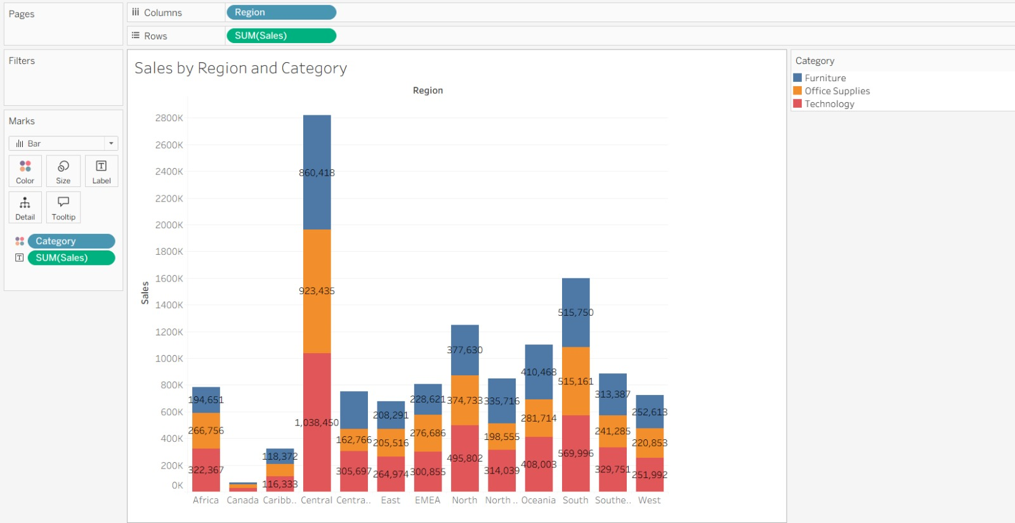
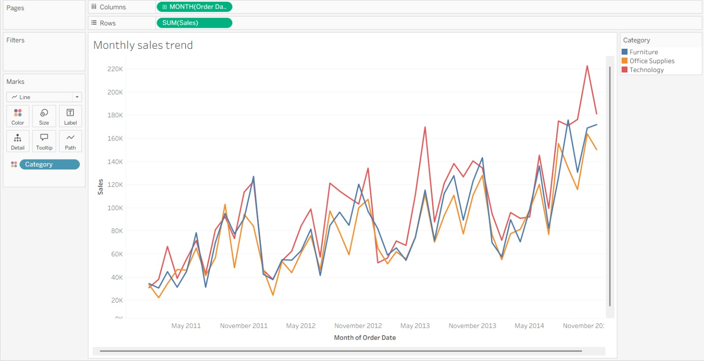
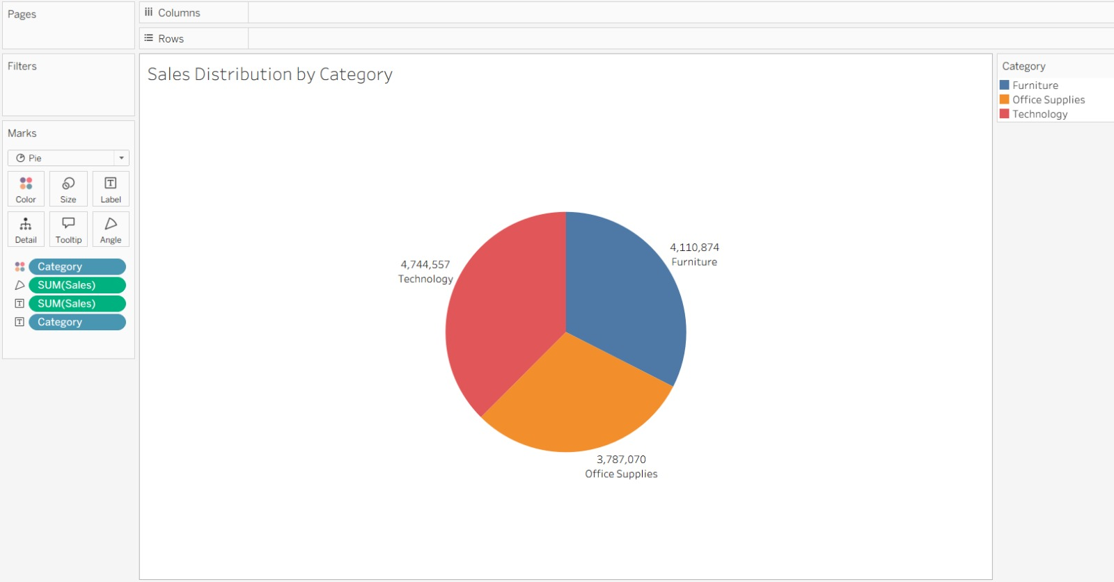

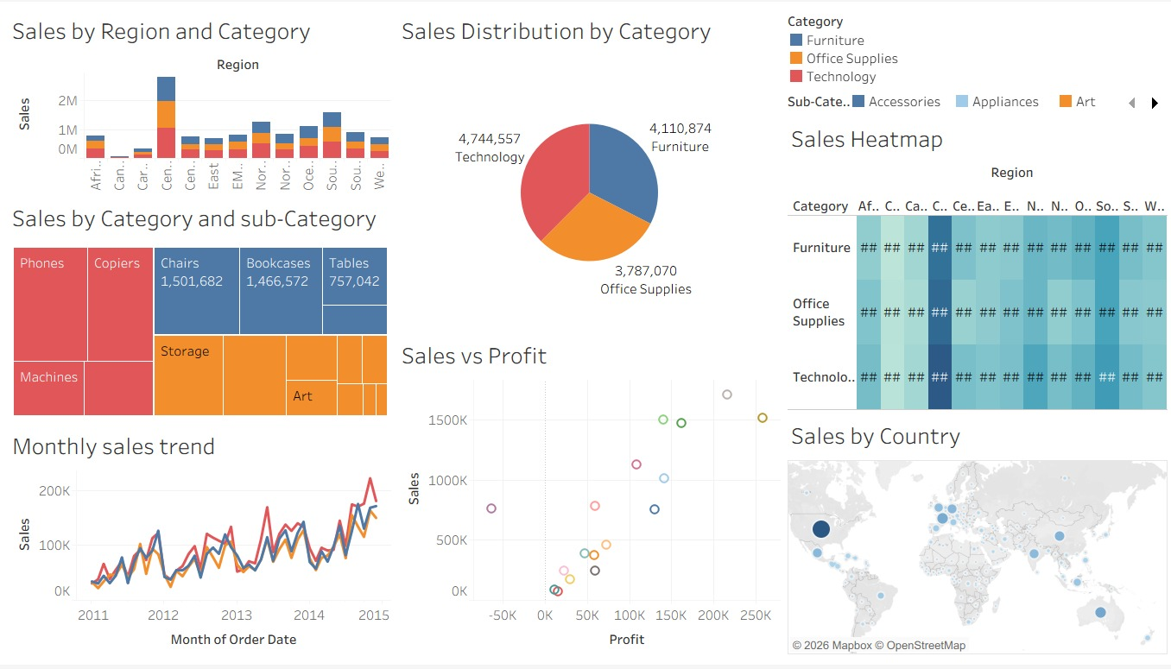

PowerBI:
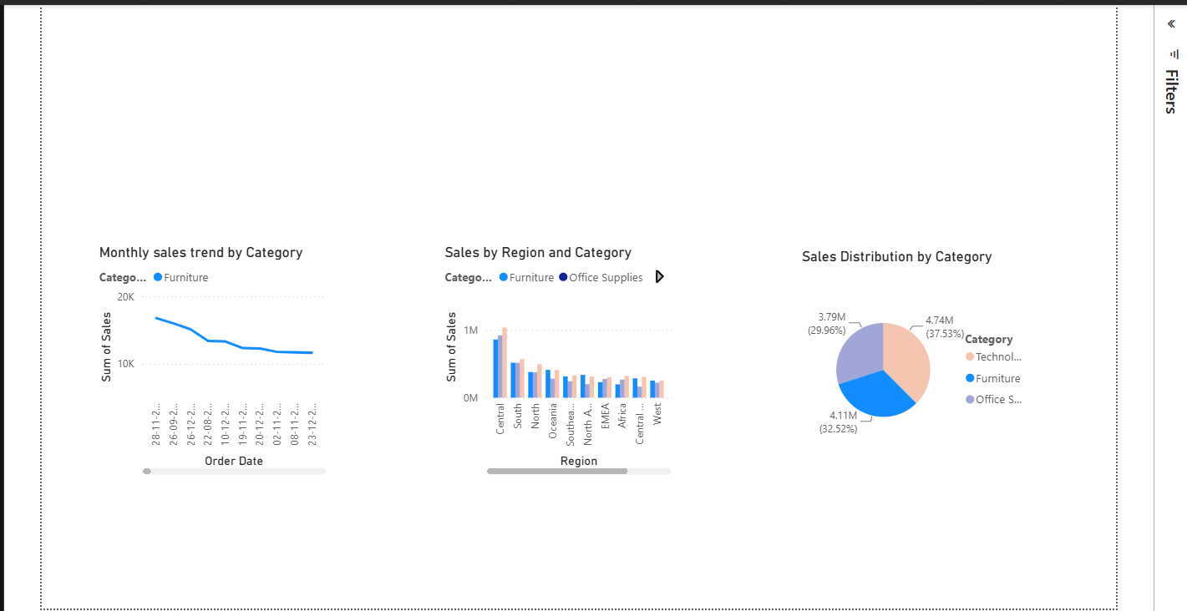

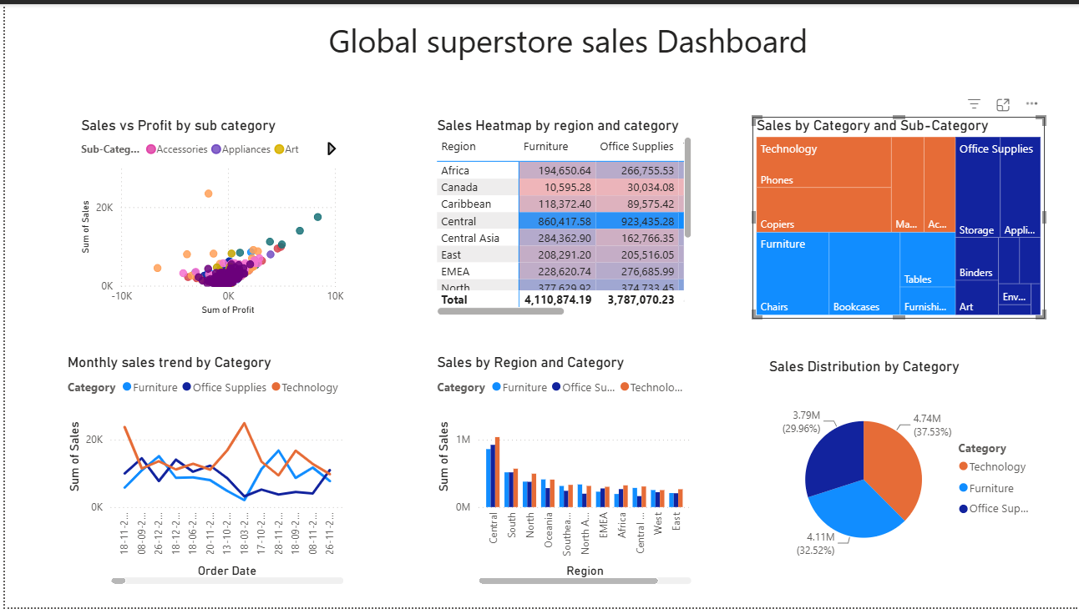

POST-LAB QUESTIONS (PROVIDE BRIEF ANSWERS TO THE FOLLOWING QUESTIONS)

Bar Chart:
What regions had the highest and lowest total sales?
The Central region had the highest total sales, while the Canada region had the lowest total sales among the regions shown.
How does the performance of categories vary across regions?
The performance of categories varies across regions. Furniture, Office Supplies, and Technology contribute differently to regional sales, with Technology generally showing strong sales in several regions. The Central region has the highest overall sales across the categories.

Line Chart:
Identify the month with peak sales.
The highest sales peak occurs toward the end of 2014, around December 2014.
Which category shows consistent growth in sales over time?
Technology shows relatively strong growth and higher sales toward the later part of the period, although all three categories show fluctuations over time.

Pie Chart:
Which category contributes the most to overall sales?
Technology contributes the most to overall sales, with approximately 4.74 million in sales.
Are there any categories with negligible sales contributions?
No category has a negligible contribution. However, Office Supplies has the lowest contribution among the three categories, with approximately 3.79 million in sales.

Scatter Plot
Is there a noticeable correlation between profit and sales?
Yes, there appears to be a positive relationship between profit and sales. In general, higher sales are associated with higher profits, although some variations and exceptions are visible.
Which sub-category shows the highest sales but low profit?
Based on the scatter plot, the exact sub-category cannot be identified clearly because the points are represented mainly by colors without visible sub-category labels. However, the plot shows that some sub-categories have relatively high sales but comparatively lower profit.

Heatmap

Which region-category combination has the highest sales?
The Central region – Technology combination appears to have the highest sales, based on the darkest cell in the heatmap.

Identify any regions with poor sales performance across all categories.
Canada shows relatively poor sales performance across all three categories compared with the other regions.

Geographical Map

Which country has the highest total sales?
The United States has the highest total sales, as indicated by the largest and darkest bubble on the map.

Are there regions with minimal or no sales?
Yes. Several countries have very small sales values or no clearly visible sales, particularly countries outside the major markets. The sales are concentrated mainly in countries such as the United States and other major markets.

Tree Map

Which sub-category dominates the sales in each category?
In Furniture, Chairs appears to be the dominant sub-category. In Office Supplies, Storage appears to have a strong contribution. In Technology, Phones appears to be the dominant sub-category.

Are there any sub-categories with unexpectedly low sales?
Yes. Several smaller sub-categories have relatively low sales compared with the dominant ones. The smaller blocks in the treemap represent these low-performing sub-categories.

Dashboard

What insights can you derive when combining all visualizations?
The dashboard shows that sales performance varies significantly across regions, categories, and countries. Technology is the highest-selling category, while the Central region has the highest regional sales. The United States is a major contributor to global sales, and the scatter plot indicates a generally positive relationship between sales and profit. The treemap also highlights important sub-categories such as Phones, Chairs, and Storage.

How do filters enhance the utility of the dashboard?
Filters make the dashboard interactive by allowing users to analyze specific regions, categories, countries, or time periods. They help users focus on selected subsets of data and quickly compare sales and performance, making the dashboard more useful for data exploration and decision-making.

ASSESSMENT

Description | Max Marks | Marks Awarded
Pre Lab Exercise | 5
In Lab Exercise | 10
Post Lab Exercise | 5
Viva | 10
Total | 30
Faculty Signature

